PROJECT REPORT OF CO-OP Project at Industry (Module-2)
ON
Dynamic SOAP Request Generation and CSV Export Utility Using C# and SQL Server
submitted in partial fulfilment of the requirements for the award of degree of

BACHELOR OF ENGINEERING
In
COMPUTER SCIENCE AND ENGINEERING

Submitted by: Supervised By:
Rishit Chadha Dr. Monika Aggarwal
2210990728 Mentor
Chitkara University


DEPARTMENT OF COMPUTER SCIENCE AND ENGINEERING

CHITKARA UNIVERSITY INSTITUTE OF ENGINEERING AND TECHNOLOGY
CHITKARA UNIVERSITY, PUNJAB, INDIA

CONTENTS

S.No. | Title | Page No.
 | Acknowledgement | iv
 | List of Figures and Tables | v
 | Abstract
1 | Introduction | 1
2 | Methodology
3 | Tools and Technologies
4 | Implementation
5 | Major Findings/Outcomes/Output/Results
6 | Conclusion and Future Scope
 | References
 | Appendices

DECLARATION

I hereby certify that the work which is being presented in the project report entitled Dynamic SOAP Request Generation and CSV Export Utility Using C# and SQL Server in partial fulfilment of requirement for the award of the degree of Bachelor of Engineering (Computer Science and Engineering) submitted in the department of Computer Science and Engineering at Chitkara University Institute of Engineering and Technology, Chitkara University, Punjab, India, is an authentic record of my own work carried out under the supervision of Dr. Monika Aggarwal. The matter presented in this project report has not been submitted in any other university/institute for the award of any degree.

Place: Rajpura Rishit Chadha
Date: 13th May 2026 2210990728

This is to certify that the above statement made by the candidate is correct to the best of my knowledge and belief.

Dr. Monika Aggarwal
Mentor
Department of Computer Science and Engineering
Chitkara University Institute of Engineering and Technology,
Chitkara University, Punjab, India

ACKNOWLEDGEMENT

I would like to express my sincere gratitude to my mentor, team members, and organization for their constant guidance and support throughout the completion of this project. The experience gained during the project significantly enhanced my technical and professional skills.

ABSTRACT

1 Introduction

The project was developed to automate SOAP request creation for enterprise systems. It dynamically fetches layout metadata from SQL Server databases and generates reusable XML requests for API integration and testing.

2 Methodology

The application validates user input, connects to SQL Server, retrieves layout field metadata using stored procedures, and dynamically generates SOAP XML requests. The output is stored in XML and CSV files for future use and validation.

3 Tools & Technologies

Programming Language: C#
Framework: .NET
Database: SQL Server
Connectivity: ADO.NET
File Formats: XML and CSV
IDE: Visual Studio

4 Implementation

The project implementation includes modules for database connectivity, metadata processing, SOAP XML generation, CSV export functionality, exception handling, and output file creation.

5 Major Findings/Results

The application successfully generated SOAP XML payloads dynamically based on database metadata. The CSV export utility functioned correctly, reducing manual effort and improving consistency in API testing and enterprise integration workflows.

6 Conclusion & Future Scope

The project successfully automated SOAP request generation and metadata export processes. Future enhancements may include GUI-based execution, REST API support, automated token management, and integration with testing frameworks.

REFERENCES

Microsoft Documentation – C# Programming Guide
https://learn.microsoft.com/en-us/dotnet/csharp/

Microsoft Documentation – ADO.NET Overview
https://learn.microsoft.com/en-us/dotnet/framework/data/adonet/

Microsoft SQL Server Documentation
https://learn.microsoft.com/en-us/sql/sql-server/

SOAP Web Services Tutorial – W3Schools
https://www.w3schools.com/xml/xml_soap.asp

XML Processing in .NET Documentation
https://learn.microsoft.com/en-us/dotnet/standard/data/xml/
Oracle SOAP Web Services Documentation
https://docs.oracle.com/cd/E24329_01/web.1211/e24965/fundamentals.htm

CSV File Handling in C# – Microsoft Documentation
https://learn.microsoft.com/en-us/dotnet/standard/io/

Visual Studio IDE Documentation
https://learn.microsoft.com/en-us/visualstudio/

Enterprise Application Integration Concepts
https://www.ibm.com/topics/application-integration

Software Engineering Principles – Ian Sommerville
Pearson Education Publications

APPENDICES

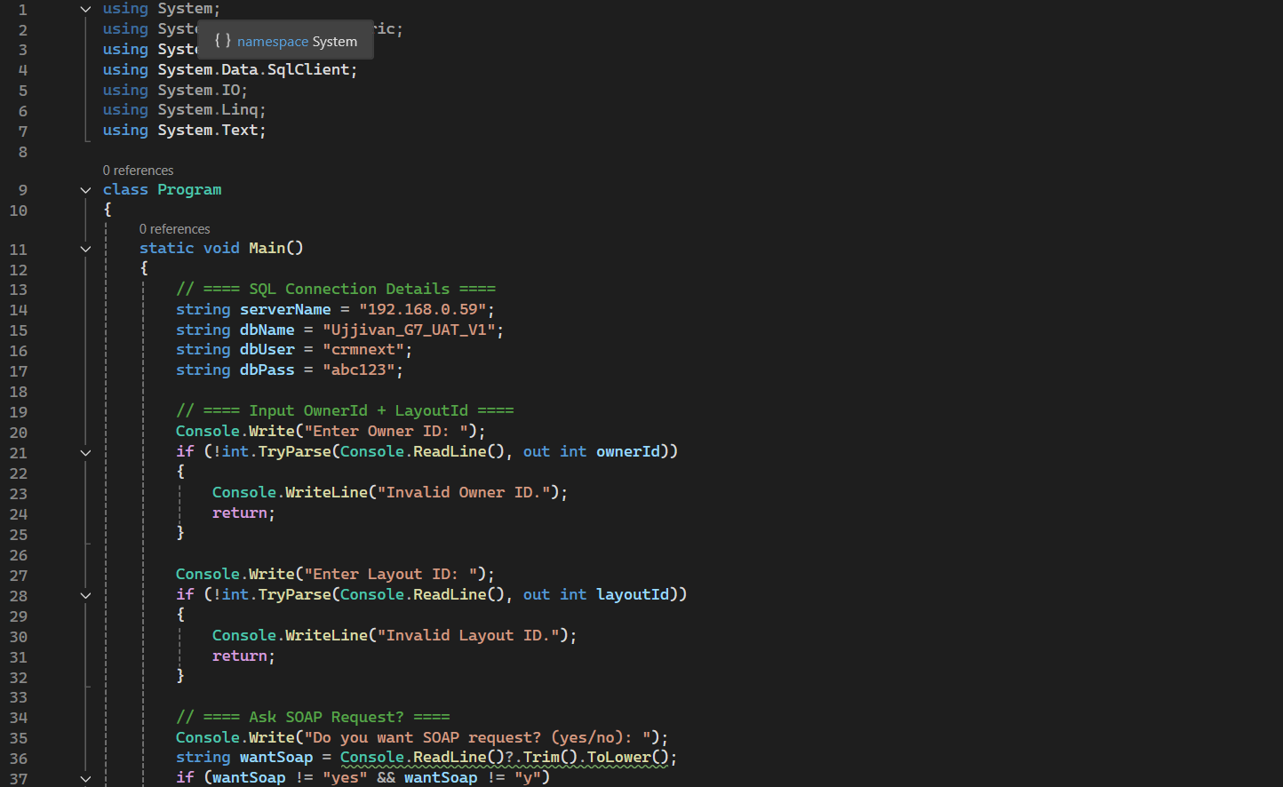

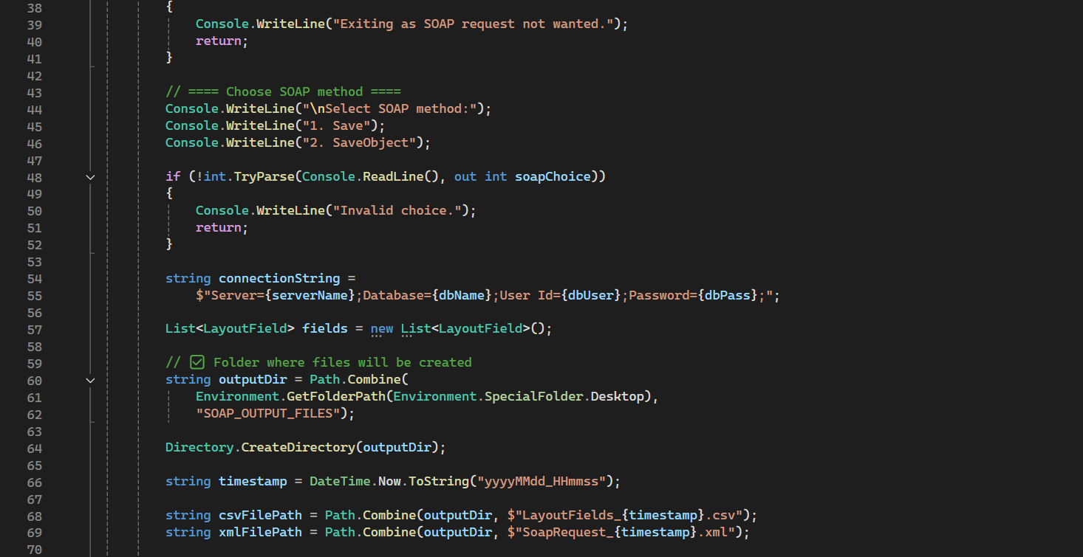

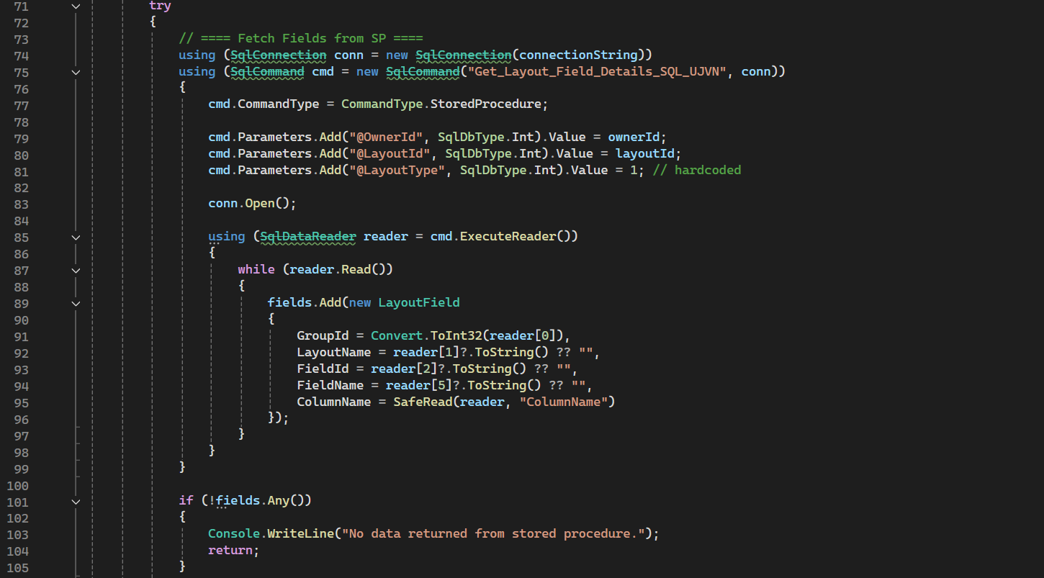

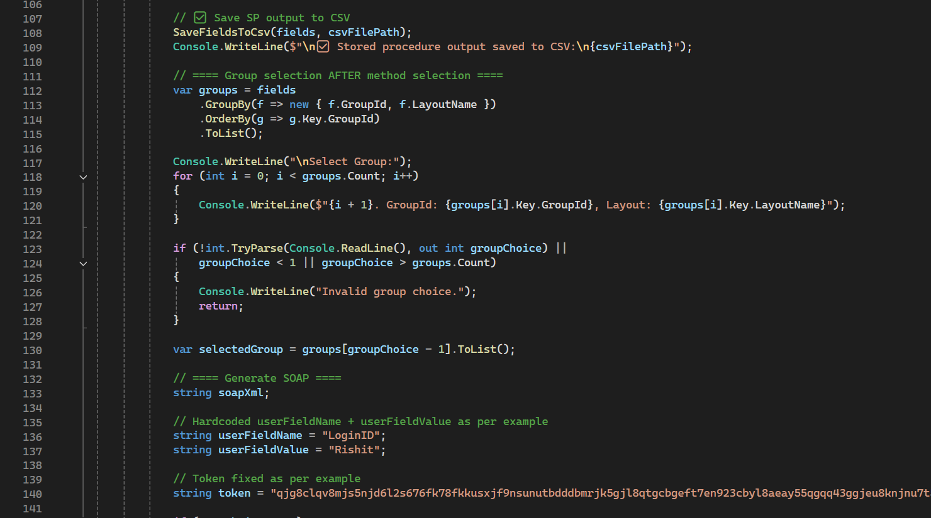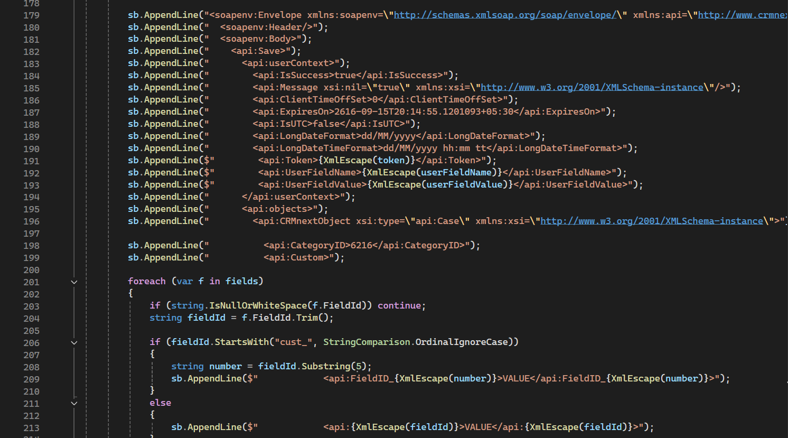

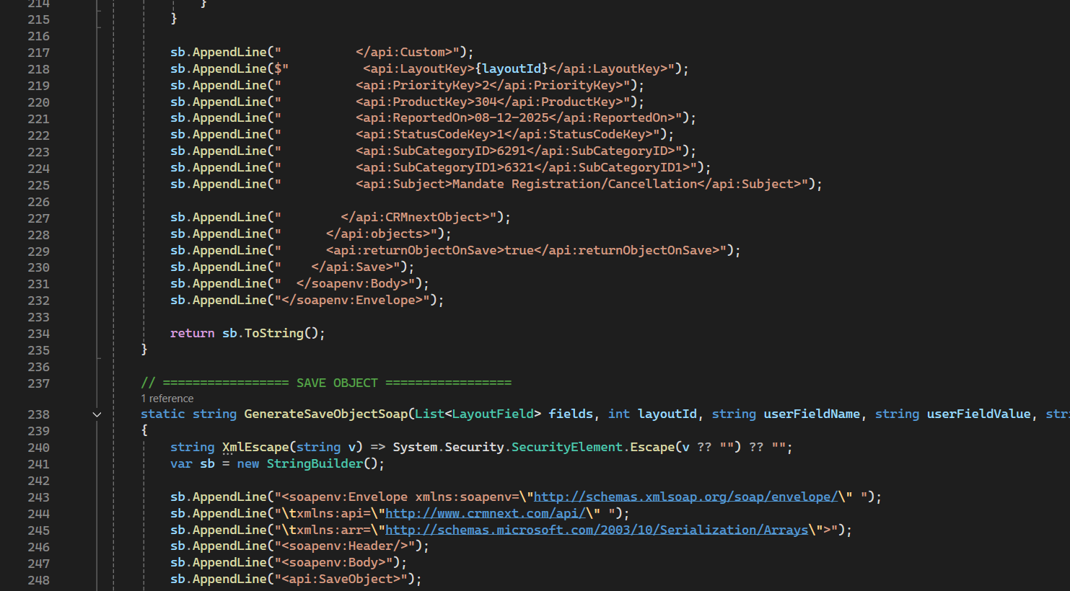

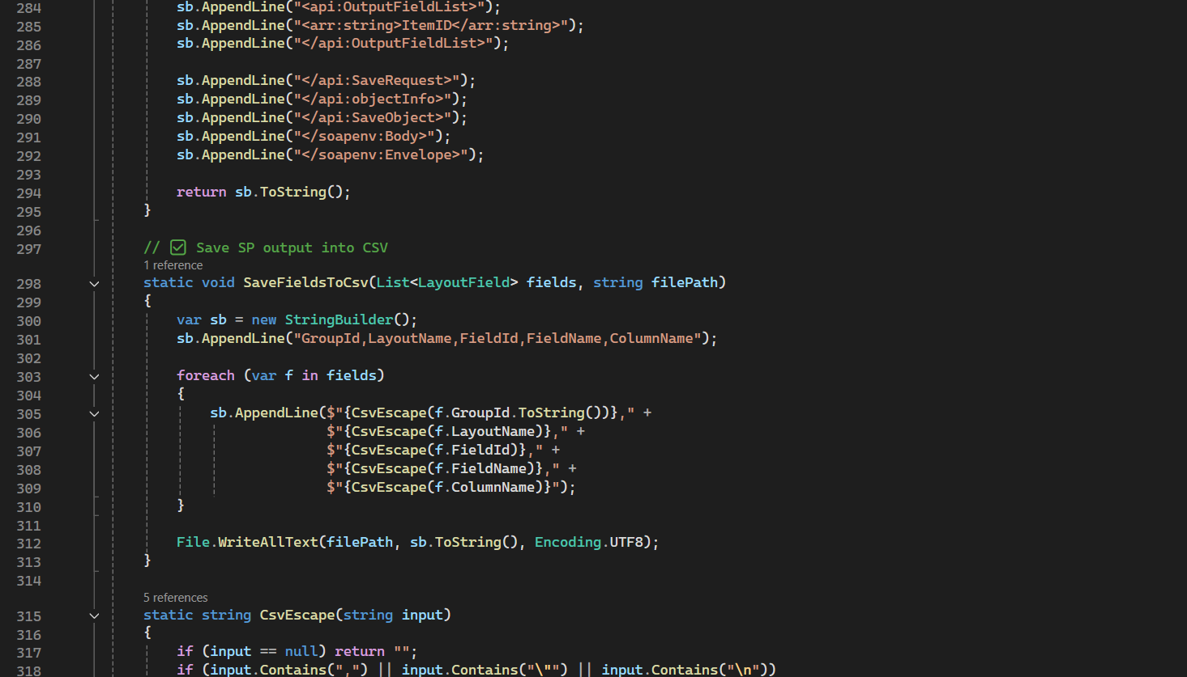

OUTPUT
